

# Department for Health

# ASSIGNMENT COVER PAGE

**Research Project Design.**

**Student Name: Liam James Robinson**

**Unit name: Research Project Design (RPD)**

**Programme: MSc Sports Physiotherapy.**

**Assignment name: Research Protocol - Final Proposal**

**(delete as relevant)**

|  |
| --- |
| **Final Version** |
|  |

**Date submitted: 4th March, 2015 (Approved Delayed Submission)**

**Supervisor’s name: Main – Dr. Craig Twist (External)**

**2nd –** **Dr. Keith Stokes (Internal - Bath)**

**3rd - Dr. Aaron Coutts (External)**

***Declaration:***

*I certify that I have read and understood the entry in the Student Handbook on Cheating and Plagiarism and that all material in this assignment is my own work, except where I have indicated with appropriate references. In line with* [*Regulation 15.3(e),*](http://www.bath.ac.uk/regulations/) *by submitting an electronic copy of this work I agree that it may be submitted to a Plagiarism Detection Service for quality assurance purposes.*

|  |
| --- |
| **PASS/** |

|  |  |
| --- | --- |
| **Assessment criteria:** | **Bath University Supervisor’s comments and feedback:** |
| **Searching and critical evaluation of the existing literature base in order to explain and develop research ideas within the context of current knowledge.** | The background information is comprehensive and well presented. It is clear that a great deal of thought and effort has gone into this section. |
| **Research question and evidence of novelty and scope to add to knowledge.** | The question is novel and has the potential for applied impact |
| **Aim; SMART objectives and their relation to the overall aim of the project.** | The aims are very clear – the objectives are written such that they are difficult to distinguish from the aims (i.e. I would expect them to be specific steps to achieving the aims), but this is not a major problem |
| **Philosophy, with reference to underpinning theory and justification of approach taken.** | The approach is well justified by the information presented |
| **Design and methods proposed. Appropriateness to the research question, stated aim and objectives.** | The question is clearly stated and the design and specific methods are appropriate for to answer the question in an applied environment. This is a very clear proposal that has been carefully put together. |
| **Consideration of ethical implications of research.** | Ethical issues have been considered |
| **Project plan and feasibility.** | The project plan is carefully laid out and is manageable |
| **Standard of presentation.** | The proposal is very well presented |

|  |
| --- |
| ***General Comments:***  Overall this is a very good proposal that is very clear and identifies all of the key issues. |



# Department for Health

# MSc Research Proposal Template

***NB This template must be completed with reference to the accompanying document “Writing a Research Protocol - Guidance Notes”***

**All researchers involved in this project** *list team members, roles within project and proportion of the work for which the member is responsible.*

|  |  |  |
| --- | --- | --- |
| **Name** | **Role** | **% contribution to work** |
|  |  |  |
| Liam James Robinson | **Student** – Main Researcher. | 75%+ |
|  |  |  |
| Dr. Craig Twist | Main Supervisor (External) | 15% (Frequent Skype, Emails) |
|  |  |  |
| Dr. Keith Stokes | Supervisor (Internal - Bath) | 5% (Email/Document Feedback) |
|  |  |  |
| Dr. Aaron Coutts | 3rd Supporting Supervisor (External) | < 5% (Frequent Skype, Emails) |
|  |  |  |

# Title of the Project:

Neuromuscular, physiological and perceptual responses to linear vs. multidirectional high intensity running sessions in academy rugby union players.

# Summary of the Project - (*View this as an abstract of your intended project):*

This study will examine the neuromuscular, physiological and perceptual responses to two types of modified high intensity running sessions typically used in rugby training environments, i.e. linear (L) vs. shuttle run with multiple changes of direction (COD). Measures of muscle function (i.e. knee flexion, extension, shallow range eccentric hamstrings and adductor squeeze) will be recorded before and immediately after both protocol A (linear) and B (multidirectional). Blood lactate concentration ([La]), rating of perceived effort (RPE), heart rate (HR) and a perceptual measure of fatigue questionnaire will also be measured at each trial. Movement characteristics during running will also be recorded using a 10Hz GPS system. Subjects will run at maximal speed during 30 m shuttles set up in accordance to either protocol A or B. Each 30m of running will be followed by 30 m walking at <1 m/s. Subjects will run a total distance of 1500 m in both protocols. Neuromuscular markers will be reassessed at 48 hours post running.

*Results:*

*Conclusion:*

**Lay Person’s Summary of the Project -** (suitable for use by the media)

*Avoid the use of highly technical terms. Be brief and describe the overall aims of the research and expected outcomes in a manner the general public will understand.*

The outlined study will look to examine the fatigue characteristics of academy rugby union players during training. Despite much being known regarding the gross demands of field sports, little is understood regarding how fatigue markers respond when assessed in a typical rugby training type environment inclusive of multiple changes of direction. The aim of this study therefore is to investigate fatigue responses between high intensity running sessions of either linear running or running with these changes of direction.

It is hoped that the findings might enable coaches and trainers to better understand the internal loads imposed on the body by multidirectional movements, ultimately presenting implications for future specific training prescriptions.

**Keywords/Phrases describing the research and its approach -** *no more than 4 terms.*

Changes of Direction (COD), Fatigue, High-Intensity Exercise, Rugby Union.

# *PROJECT PROTOCOL*

**Background/Introduction:**

*Set out the rationale for the piece of research, including a synthesis and analysis of previous research in the same field.*

Rugby union is a sport characterised by repeated, high-intensity work periods of relatively short duration (Duthie, Pyne & Hooper, 2003: Duthie et al, 2006). At the elite level, while the development and implementation of an effective training programme is deemed essential with regards to both rehabilitation and preparation purposes to meet the physical demands of the sport (Gamble, 2004), the complexity in its delivery lies within establishing a correct balance between its volume and content.

Aspects of high-intensity intermittent efforts (HIE) performed within short distance running tasks are often interspersed throughout team sport training (Gabbett et al., 2012). The inclusion of game specific HIE such as accelerations, decelerations and changes of direction (COD) however come at a cost given they bring about both immediate and prolonged symptoms of fatigue (Hader et al., 2014). Defined as sensations of tiredness and associated decrements in muscular performance and function (Abiss & Laursen, 2005), fatigue is well understood as a multidimensional process resulting from activity. While previous work has increased our understanding of the gross demands of field sports (Gregson et al, 2009), much of the available research has only supplied data describing the physiological and metabolic costs of such exercise (Dellal et al, 2009: Buchheit et al, 2010: Alaphilippe et al, 2012).

With lower limb muscle activation having been previously reported to increase during COD tasks compared with straight-line (Beiser, Lloyd & Ackland, 2003), there still remains a failure to fully consider the additional potential fatigue effects of combined COD, acceleration & deceleration occurrences such as may be used within typically prescribed HIE. Despite Akenhead et al. (2014) presenting a novel piece touching on similar concerns, the absence of a valid neuromuscular fatigue measure has made it difficult to quantify the influence of COD in conjunction with acceleration and deceleration and thus any implementation into practice has stuttered.

As knee joint stabilisation during COD and HIE is achieved through responsive muscle activity (Beiser, Lloyd & Ackland, 2003; Hader et al, 2014), neuromuscular fatigue as a result of prolonged HIE has been postulated to potentially play a role in the promotion of extreme lower biomechanics stemming from the resultant suboptimal muscle activation (Sanna & O’Connor, 2008). Eccentric muscular contractions as present during periods of HIE decelerations are also well documented as being a potent stimulus towards the inducing of gains to the neuromuscular system (Hortobogyi et al, 1996) and thus the effects of such combined exercise prescriptions such as discussed may help bridge the complexity in establishing balance between volume, content and potential for injury.

A more thorough understanding of the multidimensional fatigue responses towards typically prescribed HIE programs could therefore have important implications for future specific training prescriptions. Accordingly, the aim of this study is to investigate the neuromuscular, physiological and perceptual responses towards two types of modified HIE running sessions typically used in rugby training environments. In addition, it is hoped that potential findings may enable coaches and trainers to find an effective balance between potential improvements in performance and potential for injury during prescription.

# Research Question/Hypothesis:

Does the inclusion of accelerations, decelerations and changes of direction alter the physiological, neuromuscular and perceptual response to a typical rugby high intensity exercise running programme?

# Aim of Research:

The aim is to investigate the neuromuscular, physiological and perceptual responses to two types of modified high intensity running sessions typically used in rugby training environments.

# Objectives of Research:

• To examine specifically if measures of neuromuscular fatigue are influenced when compared between two types of modified high intensity running sessions typically used in rugby training environments: i.e. linear (L) vs. shuttle run with multiple changes of direction (COD).

• To examine if measures of blood lactate concentration ([Bla]), rating of perceived exertion (RPE) and heart rate (HR) are different between high intensity linear and multidirectional running protocols.

• To assess the delayed neuromuscular fatigue response compared to baseline values of isometric knee flexion, extension, low range eccentric hamstrings and groin squeeze in the 24-48 hours after the running protocols.

**Research Design - Statement of methods:**

*Design and methods to be used. Include details of guiding methodology, setting, participants (and intervention if appropriate), recruitment, sampling strategy(ies), data collection method(s), including outcome measures and method of measurement and your approach to data analysis etc. as outlined in the guidance notes.*

***Methodology:***

***Quantitative Study: -***

Taking quantitative measures for the data collection will generate significant numeric data that can be ordered, added together and/or counted to define frequencies from the data observation. Quantitative investigations facilitate the search for ‘distinguishing characteristics’ within the data and as a result, this method is well suited towards this particular project’s primary aims. The data generated from this type of approach will allow for more descriptive statistical analysis and thus broadens the way the data can be handled, analysed and ultimately interpreted.

***Design Strengths: -***

A randomised repeated measures crossover design will use the same subjects for each trial of the research (see below) whilst maintaining a controlled environment in which the research project will take place. These aspects both aim to minimize participant bias and thus aid confidence in the potential findings.

Using a randomised repeated measures crossover design means that there is less chance of natural variation between individuals being responsible for the skewing of any results due to all participants completing all aspects of the testing in the design (Prog A and Prog B). This method therefore requires fewer participants and resources and would be most practical towards the potential research population given the nature and aims of the project.

Prog A will differ to Prog B (but will be matched for distance (m)) – due to the nature of the design, no learning effect will take place that could then influence findings.

***Bias Consideration:***

***Selection bias:*** -

All participants will be from selected from the same squad (u20s) and train together at the same level (Australian academy rugby union). This will minimize any selection bias, and will make findings relevant towards other similar academy rugby union populations. The sample will thus be representative of the population that these results will look to influence.

***Observer or measurement bias:***

Measurements will be taken using previously validated (in research) measuring equipment that has will be calibrated according to the manufactures instructions before use during this project.

Equipment to be used by the main assessor will include:

Baseline© Push/Pull Dynamometer,

Pressure Cuff Sphygmomanometer,

The main researcher (myself) will be the primary (and only) assessor for all neuromuscular measures of strength, minimizing any assessor bias. The main researcher is a 7 year post-graduate in physiotherapy and often uses dynamometry/sphygmomanometer measurements in both sports and private clinic.

Dynamometry strength assessments via the ‘Baseline© Push/Pull Model’ will be assessed in accordance to the process described in:

‘Whitely (2012). Correlation of isokinetic and novel hand-held dynamometry measures of knee flexion and extension strength testing. *Journal of Science and Medicine in Sport*, 15, p444-450’

Pressure cuff Sphygmomanometer assessment for groin squeeze will be conducted in line with the process outlined in:

‘Delahunt, E., Kennelly, C., McEntee, B.L., Coughlan, G.F., Green, B.S. (2011). The thigh adductor squeeze test: 45 of hip flexion as the optimal test position for eliciting adductor muscle activity and maximum pressure values. *Manual Therapy*, 16: 476-480’

***Methods:***

***Participants:***

Approximately ~25 male Australian academy rugby union players will be selected from the same rugby club academy. All players will be derived from the u20s squad of which the main author has access to.

As the target population of potential results are relevant towards a rugby population, the participants being used are relevant.

***Exclusion Criteria:***

• All players will be assessed prior to any inclusion for injury and selection for potential invitation will ultimately rely on the main author (7 years post graduate physiotherapist) clearing the players via a formal, in-use (within club), musculoskeletal (MSK) assessment.

• Only players that would otherwise be involved in full contact/non-restricted/non-modified training sessions at the time which the study is being conducted will be selected as invitees for participation.

• Any player not given permission by the club will also be excluded, despite them being eligible based on MSK assessment. The parent club will have ultimate say on inclusion of the player in the outlined study.

***Inclusion Criteria:***

• The player must be within the u20s academy squad for the 2015 season and must have had MSK clearance from the assessing physiotherapist prior to being invited for consideration of participation.

• Participant must also have clearance from the club prior to being invited – (after MSK screening has been completed)

•

***Sampling:***

Given there are 30 registered players within the rugby union academy in which the main author works, this number will constitute the initial sought after sample size.

The group in question is of particular interest towards this research piece (aims/objectives) and thus has been selected based on the purpose of the study and the knowledge of this population. The sampling technique to be used is therefore that of a ‘purposive’ method. Given the nature of the study, this population is already working/training within the academy environment and are thus deemed to likely already meet the eligibility characteristics to be able to perform the desired tasks within the data collection stages.

The research design (crossover, repeated measures) means that there is less chance of natural variation between individuals being responsible for the skewing of any results (due to all participants completing all aspects of the testing in the design) and as a result this method design requires fewer participants. The aim therefore is that ~25 participants will be eligible after the exclusion criteria is performed and potential other confounding variables are accounted for.

***Recruitment Procedures:***

All players are registered members of the academy at which the main author works (Super Rugby Club). Permission to invite members of the u20s to participate in this research has been granted by the club.

All registered academy players (~30) will be addressed by the main researcher (lead academy physiotherapist) well in advance as to the research project proposal. At this stage, the academy players will receive a short presentation by the lead researcher then be given the prepared ‘subject information sheet’ which will outline all aspects of the project described. Subjects will then be asked to volunteer for the project prior to a defined date if they feel they would like to take part. The initial phase of subject recruitment will be that of identifying willing subjects and commence MSK screening. Subjects will therefore be required to **volunteer** and then consent (**via informed consent form**) to phase 1 of subject recruitment (MSK screen for research purposes only).

From those consenting volunteers, a MSK screen will be completed by the lead researcher. After MSK screening is complete, those players who then still meet the inclusion criteria will be invited to formally participate in the research and further written information regarding the research will be issued along with additional **informed consent forms**.

Data will then be destroyed for those then not meeting the inclusion criteria at this stage.

***Allocation to groups:***

A randomised repeated measures crossover design will be used so that all participants undergo both Protocol A (linear) and Protocol B (change of direction).

For those participants who attend the familiarisation day, the order of performance for the data collection days will be assigned randomly via drawing numbers from a hat. In ascending number order, each participant will then be given an arrival time at the data collection setting (as noted previously). Participant order and time of arrival is to remain the same for Protocol (A) and Protocol (B). This is to limit the effects of the circadian variations on the measured variables, particularly on HR measures.

GPS units will allocated numbers then each number will be randomly allocated to each participant. While these devices won’t leave the data collection setting, the device issued will remain the same for completion of Prg A and Prg B as to minimise inter-device variability.

***Retention Strategies:***

The main researcher will send text messages 48 and 24 hours prior to scheduled time of arrival for all participants. For those who do not have a phone, a contact number will need to be provided for the duration of the study. This aims to remind participants to attend as scheduled.

[? unsure of more – will liaise with Alan Buckingham prior to ethics submission]

***Setting:***

The setting will be that of the normal academy training location for the u20s group as discussed. All data will be collected at the address: IKON Park, Royal Parade, Carlton, Melbourne, VIC, Australia. This address will also be used for all the pre-assessment MSK screening and trial days before participants complete Protocols A and B (Data Collection).

A maintained grass rugby pitch, used throughout the year by the u20s squad, will be used for all running protocols. Environmental conditions including temperature, humidity & wind direction will be recorded prior to the commencement of any running.

An area will be marked on the pitch where all assessments will take place (Registration/GPS, Neuromuscular Assessment, Lactate Measurement, Rate of Perceived Exertion). An area will also be marked where the warm up will take place prior to the running trials. The required shuttle distances will also be marked on the floor across the grass field area.

***Procedures & Equipment:***

**Neuromuscular Assessment (A):**

*Via*: Baseline© Electronic Push/Pull dynamometer Model 12-0343 and rated to 225 kg (Fabrication Enterprises Inc., NY, USA).

**Neuromuscular Assessment (B):**

*Via*: Commercially available (Welch Alyn) Sphygmomanometer: Pre-Inflated to 20mm Hg.

**Blood Lactate:**

Via: Lactate Pro/Plus Portable Analyser – (Arkray Inc, Japan).

**RPE:**

*Via*; BORG 6-20 & Session RPE 1-10

**GPS:**

*Via*: 10Hz GPS units (MinimaxX s5, Catapult Innovations, Scoresby, VIC, Australia)

***Data Collection materials and procedures:***

*Neuromuscular Assessment: (****A****)*

A hand held dynamometer (Baseline© Electronic Push/Pull dynamometer Model 12-0343) is to be used in the data collection for neuromuscular assessment of isometric quadriceps contraction at 30◦ of knee flexion seated, isometric hamstrings contraction at 30◦ of knee extension seated, and shallow range eccentric hamstrings contraction between 45◦ and 15◦ of knee flexion prone. This equipment will be calibrated prior to use according to the manufacturer’s operational manual and all measures using this equipment will be conducted by the main researcher only.

*Familiarisation Day:*

Accepted participants will arrive at a pre-arranged familiarisation day to be organised by the main researcher. Here, each participant will undertake a mock assessment of the above neuromuscular measures, in the above stated positions. The aim of this is to familiarise the participants with the equipment and measuring techniques prior to the official days of data collection.

*Official Testing Days:*

At the familiarisation day, all participants will be issued an assessment start time for the official testing days (Prog A and Prog B). This time will be used for both assessment days and will be recorded by the lead researcher. Text messages and a reminder phone call will be delivered to each participant at 48 and 24 hours prior to the testing commencing.

After arrival and registration, each participant, in time order will report to a team member. Participants will then give additional consent on the day and then begin a standardized 10 minute warm-up procedure designed by a strength and conditioning coach (helper 2). Participants neuromuscular assessments will then begin in the procedure as outlined below. This procedure will take place immediately after the 10 minute warm up (prior to any running) and then at 4 minutes post completion of the shuttle run program (as [BLa] will be taken at 3 minutes post).

*(A) Isometric knee extension:*

With the patient sat on the edge of a ready prepared plinth, the dynamometer will be switched on and be ready to use in ‘tension peak’ mode. The dynamometer belt will then be wrapped around the distal shank at the level of the malleoli with the bed height and attached dynamometer belt being adjusted so that knee flexion angle is 30◦ and belt is perpendicular to shank. A goniometer measurement will ensure that the starting position is 30◦ knee extension.

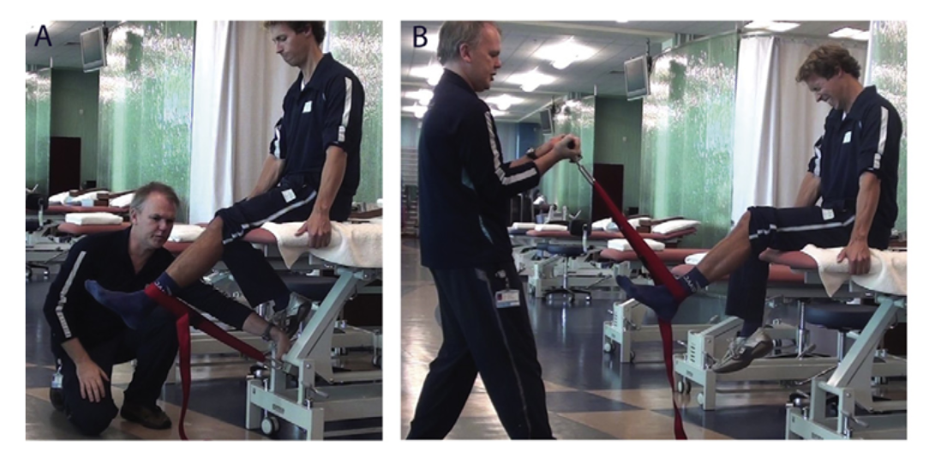On instruction, the athlete will attempt to extend the knee maximally for a period of approximately 3s which will be timed by a helper. The main researcher will ensure all equipment remains in place during the test, and will then note the dynamometry value after the 3s exertion. The same test will be repeated 3 times with the maximum value being recorded.

*(B) Isometric knee flexion:*

With the patient sat on the edge of a ready prepared plinth, the dynamometer will be switched on and be ready to use in ‘tension peak’ mode. The dynamometer belt will then be wrapped around the distal shank at the level of the malleoli with the bed height and attached dynamometer belt being adjusted so that knee flexion angle is 30◦ and belt is perpendicular to shank. A goniometer measurement will ensure that the starting position is 30◦ knee extension.

On instruction, the athlete will attempt to maximally flex the knee which will be isometrically resisted by the main researcher for approximately 3s. This time will be monitored by the helper. The same test will be repeated 3 times with the maximum value being recorded.



*(C) Eccentric knee flexion:*

With the patient lying prone on the ready prepared plinth, the dynamometer will be switched on and be ready to use in ‘compression peak’ mode. The dynamometer belt will then be wrapped around the distal shank in line with the malleoli.

The patients starting position will be 45◦ of knee flexion in prone, which will be measured by a helper whilst the main researcher maintains the dynamometer position as shown in the below picture. On instruction, the athlete will attempt to perform a maximal isometric contraction for approximately 2s and is then instructed to extend the shank through to the final position of 15◦ knee extension. During this motion, the dynamometer will be pulled eccentrically and move through approximately 30◦ of knee extension to the final position of 15◦ knee extension. The main researcher will take note of the final value and the same test will be repeated 3 times with the maximum value being recorded.

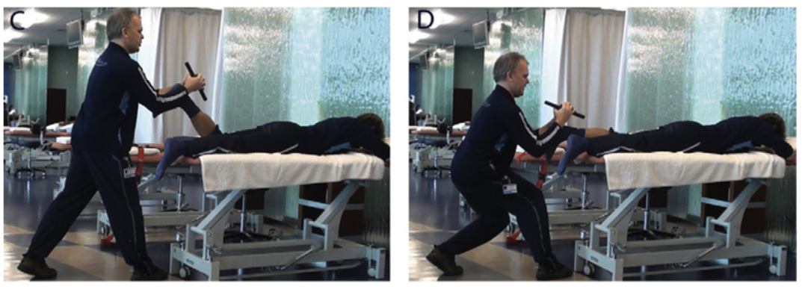

*Test time:*

5 -7 min for completion of all measures.

*Neuromuscular Assessment: (****B****)*

Upon arrival at the familiarisation session as discussed previously, each participant will be given a demonstration of the sphygmomanometer testing procedure. Here they will undergo several practice trials as will be required on the official testing days.

*Official Testing Days:*

Upon completion of neuromuscular assessment (A), participants will then be required to perform the thigh adductor squeeze test immediately after. Participants will be requested to lie in the supine position upon the provided plinth and the main researcher will facilaite placing the participant’s hips in the position of 45° hip flexion and knees at 90° of flexion. Both these angles will be measured by the main researcher using a goniometer. As discussed, this method used is adapted from the paper by Delahunt et al (2011) and is in line with best practice.

The sphygmomanometer will be pre-inflated to 20mmhg as outlined by Delahunt. Once the patient is comfortable and the researcher is ready, the sphygmomanometer cuff will be placed between the knees of the supine participant.

On instruction, the participant will be asked to squeeze the cuff as hard as they can. The main researcher will monitor the reading and record the value. The main researcher will then repeat the same test 3 times with the maximum value being recorded.

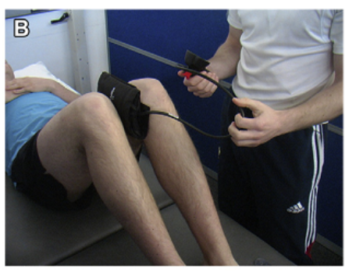

*Test Time:*

2 minutes

Blood Lactate ([BLa]) Analysis:

[BLa] will only be required to be taken once during both Prog A and Prog B. As participants complete the shuttle run testing, they will then be asked (by a team helper) to walk towards the [BLa] assessment station. The helper will commence a stopwatch timer upon completion of the shuttle run programme and at 3 minutes post shuttle completion will assess the [BLa] using the outlined lactate analyser machine.

Using the lactate analyser, participants will provide a 5µl capillary blood sample from a fingertip for analysis of blood lactate concentration ([BLa]) 3 min after completion of the running protocol. The sample will be placed into the analyser and onto the test strips, where the recorded value will be noted by the team helper. After use, the used test strips and sample tester will be disposed of in a blood and sharps designated bin which, after completion of all samples will be disposed of in a correct manor in line with such hazardous medical waste.

The accuracy of the analyzer will be checked before each test using standards provided with the machine and will also be calibrated prior to each test session (A) and (B) according to the manufacturer’s instructions. The suitability and reproducibility of this analyzer has been previously established throughout the physiological range of 1.0 – 18.0 mmol.L−1.

*Test Time:*

2 minutes

*Rate of Perceived Exertion (RPE):*

All participants will be inducted at the familiarisation day on the 6-20 BORG RPE scale and how it will be used within the project. In addition, the 1-10 Session RPE scale will also be discussed, and opportunities to use both will be an aim of the day.

Participants will be asked to measure their rate of perceived exertion at pre-determined times during the data collection days. These times are outlined below.

With the RPE scales printed out, each participant will be asked by a designated team helper to rate, on the given scale, how they perceive their current level of exertion at the times as stated. This rating will then be recorded by the team helper.

The pre-determined times are as follows and is correct for both Prog A and Prog B:

6-20 Scale RPE:

Prior to Warm Up

Post Warm Up

At active recovery walk (30s) on the 300m, 600m and 1200m and 1500m (completion) mark.

1-10 Session RPE:

15 minutes post completion of running protocol.

At completion of the running protocol, a team helper will then commence a stopwatch timer for the given participant. The participant will then undergo [BLa] assessment at 3 minutes post completion of the running program, and then neuromuscular assessment A and B immediately after. With session RPE being required to be taken at 15 minutes after completion of the shuttle running, the team helper will then ask for a perceived exertion score on the 1-10 session RPE scale when the stopwatch reaches 15 minutes.

*6-20 RPE**1-10 RPE*

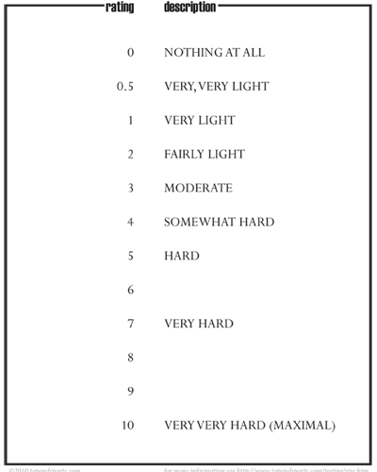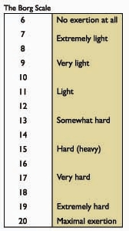

*GPS:*

GPS units will be randomly assigned to each player at the familiarisation session, with each player retaining the same GPS unit for protocol A and B to minimise influencing inter-device reliability.

At the assessment day, participants will be fitted with the GPS units by the *GPS Co-ordinator (additional team helper). Subjects will wear a vest in which the GPS will sit, placed at the middle of the upper back. GPS units will be switched on and monitored by the GPS helper.

Physical movement patterns during each running protocol will be measured using the GPS device. Measurements of distance, speed (peak and average), acceleration, and deceleration will be monitored and recorded via the manufacturer’s software on a laptop being operated by the GPS Co-ordinator.

***Data Analysis:***

Data/statistical analysis will be completed on the generated data using software tools such as SPSS (v.15, SPSS© Inc., Chicago, IL, USA), Microsoft© Excel (Office 2014) and GPS manufacturer software (Sprint 5.0, Catapult© Innovations, Australia).

***Statistical Analysis:***

All data is to be assessed with both Microsoft Excel and SPSS so that data can be expressed in terms of standard deviation (SD) and means. The normality distribution of the data will be examined using an appropriate statistical test (Shapiro-Wilk) and homogeneity of variance will be verified using again an appropriate test (Levene test).

After confirming normal distribution, a paired t-test will likely be used to analyse the pre & post neuromuscular assessment findings along with heart rate and rate of perceived exertion responses.

A one-way analysis of variance (ANOVA) with repeated measures will then be used (likely) to compare all values obtained in the 2 running protocols (A) and (B) upon completion of (B) with statistical significance being set at p≤0.05. In addition an order of testing will also be assessed for, aiding the statistical analysis and discussion.

***Handling of Data:***

Type of data being handled:

Subject height, weight, age will be recorded at the familiarisation day. All subjects will be recorded as numbers and no personal data will be released.

Numerical data as will be collected via neuromuscular assessment, blood lactate, GPS and RPE.

Musculoskeletal data will be collected during the initial musculoskeletal screening process.

Consent forms will be collected.

Media Type:

All data will be recorded on a Microsoft© Surface 3 Pro tablet computer and will be maintained by the main researcher. This computer will be password protected.

All data will be stored in individual files (Word, Excel) and will also be password protected.

The only 4 people to have access to these files at all times will be the main author (LR) and supervisors (CT), (KS) & (AC).

SPSS data will be maintained in a password protected SPSS file. This will be stored on password protected computers only.

All raw data will be backed up and stored on an external password protected hard drive in case of system malfunction. One will be issued to LR and one to CT & KS in case of loss of data.

Data handling responsibilities/privileges:

As above.

Procedural:

All data will be de-identified and data will be used up until the end of the project and submission of the research. This length of time for the study is likely to be 9-12 months after data capture. Data will then be stored for the length of time as required by the University of Bath where ethics will be requested from.

The main author and all 3 supervisors will be the only personnel to have access to the raw data.

GPS data will be accessible by the GPS co-ordinator only at the time of data collection. Once GPS data has been downloaded to the manufacturer software (after completion of A & B) this data will then be transferred to Microsoft Excel and handed to the main author. The GPS data will then be deleted from the GPS host computer and the GPS units will be reset.

Upon completion, data will be registered with ‘Library Research Services’ (Bath University) and stored in an agreed position by both supervisor and student.

# Outline Project Plan:

*Please attach to this submission an outline project plan, giving an indication of the stages of the research and an indicative time line.*

|  |  |  |  |  |  |  |  |  |  |  |  |  |  |
| --- | --- | --- | --- | --- | --- | --- | --- | --- | --- | --- | --- | --- | --- |
|  | **Year (2015) (2016)** | | | | | | | | | | | | |
| **Month** | **1** | **2** | **3** | **4** | **5** | **6** | **7** | **8** | **9** | **10** | **11** | **12** | **1** |
| Submit Final Proposal |  |  |  |  |  |  |  |  |  |  |  |  |  |
| Apply for Ethics |  |  |  |  |  |  |  |  |  |  |  |  |  |
| Discuss project with playing squad – Recruitment |  |  |  |  |  |  |  |  |  |  |  |  |  |
| MSK Screen (potential group) |  |  |  |  |  |  |  |  |  |  |  |  |  |
| Finalise available subjects |  |  |  |  |  |  |  |  |  |  |  |  |  |
| Familiarisation Day; Baseline assessments etc. |  |  |  |  |  |  |  |  |  |  |  |  |  |
| Data Collection (A) and (B) |  |  |  |  |  |  |  |  |  |  |  |  |  |
| Data Analysis |  |  |  |  |  |  |  |  |  |  |  |  |  |
| Study Write-up |  |  |  |  |  |  |  |  |  |  |  |  |  |
| Dissemination |  |  |  |  |  |  |  |  |  |  |  |  |  |

# Ethical and legal statement: (*What do you believe are the ethical/legal implications of this research?)*

|  |
| --- |
| *(All* ***BOLD*** *sheets in Appendix)*  **Description of general ethical considerations:**  Consent  Storage and use of data from MSK screen  The disclosure of data & to whom  Participants access to data & Confidentiality.  Storing of all data and its use – Data Protection. ,  Collection of blood for Blood Lactate values  Disposure of hazardous materials (blood sample etc)  **Considerations:**  Potential subjects will be contacted via the main researcher – (from within the club that players are to be selected from).  Potential subjects will be issued a **subject information sheet** which outlines all aspects of the project. This to be delivered way in advance of the project itself. *During recruitment stage.  To those subjects then indicating their willingness to be involved, an **informed consent form** well in advance of the project will then be issued. This will allow permission for MSK screening as a prior to being selected.  Once establishing a potential group (establishing willingness to be involved and informed consent given and passed MSK screen) – participants will then be issued a **written consent form** – which, will include the permission to record and store data including GPS measurement.  Data protection assurances – **Statement of data protection** to be included in the information sheet handed to all participants within the written consent form.  **Statement of Confidentiality assurances**: (will also be included within the written consent form sheet)  All blood materials used will be disposed of in a correct hazardous material waste bin and will be sent to a hazardous waste disposal unit after use – this will be the responsibility of the main researcher. |
| **Information about any external approval requirements in your country/setting e.g. UK NHS REC:**  *?* |
| **Description of how participants will be informed and consent obtained:**  Potential subjects will be spoken to by the main researcher at a pre-trial information day.  They will all be issued with a written outline of the project at this stage **(Subject Information Sheet).**  To those subjects then indicating their willingness to be involved, an **informed consent form** well in advance of the project will then be issued. This will allow permission for MSK screening as a prior to being selected.  Once establishing a potential group (establishing willingness to be involved and informed consent given and passed MSK screen) – approved participants will then be issued a **written consent form** – which, will include the permission to record and store data including GPS measurement. |
| **Considerations of any problems of confidentiality, information about data storage and**  **data protection arrangements:**  **Subject information sheet** will have details of who will have access to data and in what way it will be used. Also how it will be stored and who will have access to this  **Statement of Confidentiality assurances** will be included within the **written consent form** sheet (Appendix)  **Statement of data protection** will be included in the information sheet handed to all participants within the written consent form |
| ***How will data be stored:***  **As stated in Media Type (above) - (Within ‘handling of data’ section)** |
| **Information about data protection arrangements:**  **Statement of data protection** will be included in the information sheet handed to all participants within the written consent form  Data will be handled as explained previous. |

**PPI:**

*The NIHR and Research Councils now promote, encourage and increasingly require organisations to demonstrate evidence of PPI in the research they undertake (National Institute for Health Research 2008). Patient and Public involvement (PPI) means that people are active partners in the research process by, for example, advising on a research project, assisting in the design of a project, or in carrying out the research, rather than being the 'subjects' of research*

|  |  |
| --- | --- |
| **In which aspects of the research process have you actively involved, or will you involve patients, service users, or members of the public?** | *Please tick all that apply:*  **Design of the research**  Management of the research  Undertaking the research  Analysis of results  Dissemination of findings  None of the above |
| **Give details of patient, service users or public involvement, or if none please justify the absence of involvement.** | Main researcher has used ex-players (current coaches) to talk to in the involvement of designing some running drills that would be realistic towards a typical training session.  Also used other researches (supervisors) to discuss most appropriate testing and rational around testing.  Spoke to members of medical team and analytics team in the development of the running programs (specificity, length etc.) |

**Outcomes** **and possible implications of study:** *What will be the key outcomes of this research****;*** *what are the possible implications of this study in relation to other work?*

Content of high intensity running sessions may be important to consider in future program prescription given the neuromuscular, physiological and perceptual costs associated with the type of exercise performed within the session.

***Implications***: Knowing the physiological and fatigue characteristics when using linear vs. shuttle running practices will enable coaches to design effective training programs and better understand potential mechanisms for injury in rugby players.

# Dissemination: *What steps will you take to promote the findings of the research that you are planning?*

I will look to distribute to the IRB Science Network which I am a part of. My main supervisor is also an admin on this, so I will look to place it into the monthly newsletter that circulates from this initially.

I will also share with my colleagues within my sports MSc program, which may lead this to being read in similar departments both locally and internationally.

In discussions with my supervisor(s) over the last few months, this may be a project that we look to further given it has a solid base in which it is being developed. The aim from this piece is that I can then look towards publishing in an appropriate journal and using the experience of my supervisors to gain help facilitate this process.

**References: (not yet in full APA style)**

Abiss,C.R.,& Laursen,P.B.(2005). Models to explain fatigue during prolonged endurance cycling. Sports Medicine, 35,865–898

Akenhead (2014) Physiological consequences of acceleration during shuttle running.

Brooks et al (2005). Epidemiology of injuries in English professional rugby union: part 2 training injuries.

Buchheit et al (2010) Physiological responses to shuttle repeated-sprint running

Delahunt E, Kennelly C, McEntee BL, Coughlan GF, Green BS. The thigh adductor squeeze test: 45 of hip flexion as the optimal test position for eliciting adductor muscle activity and maximum pressure values. Manual Therapy 2011;16:476-480.’

Dellal (2009) Physiological effects of directional changes in intermittent exercise in soccer players.

Duthie, Pyne & Hooper, 2003. Applied physiology and game analysis of rugby union. Sports Medicine, 33: p973-991

Duthie, Pyne, Marsh & Hooper, 2006. Sprint patterns in rugby union players during competition. Journal of strength and conditioning res, 20: 208 – 214.

Gamble, P. (2004). A skill-based conditioning games approach to metabolic conditioning for elite rugby football players. Journal of Strength and Conditioning Research, 18(3), 491-497.

Hader et al (2014) Changes of direction during high-intensity intermittent runs: neuromuscular and metabolic responses (Karim Hader1, Alberto Mendez-Villanueva2, Said Ahmaidi1, Ben K Williams2 and Martin Buchheit2)

Longitudinal follow up of biochemical markers of fatigue throughout a sporting season in young elite rugby players. 2012 alaphilippe

Mitchell, M.L., & Jolley, J.M. (2009). Research Design Explained (7th Ed.). Belmont, CA: Wadsworth Cengage Learning

Sanna & O’Connor (2008) Fatigue related changes in stance leg.

SIROTIC AND COUTTS (2007) Physiological and performance test correlates of prolonged, high intensity, intermittent running performance in moderately trained women team sport athletes. J strength and cond res.

Whitely et al (2012). Correlation of isokinetic and novel hand-held dynamometry measures of knee flexion and extension strength testing. Journal of Science and Medicine in Sport, 15, p444-450’.

**Supervisor Approval:**

*Complete the table below to confirm that your supervisor(s) have reviewed and approved your protocol. Please include an e-signature and date or an email address and date that you received emailed confirmation from them*

|  |  |  |  |
| --- | --- | --- | --- |
| Role | Name | E-signature/ email address | Date confirmation received |
|  |  |  |  |
| Supervisor (Main – External) | Dr. Craig Twist | c.twist@chester.ac.uk | FB for MS2 on 24/2/15 |
|  |  |  |  |
| Co-Supervisor (Internal) | Dr. Keith Stokes | k.stokes@bath.ac.uk | FB for MS2 on 21/2/15 |
|  |  |  |  |
| Co-Supervisor #2 (External) | Dr. Aaron Coutts | Aaron.Coutts@uts.edu.au | Will only submit to Aaron if passed and approved – he will aid with organisation/equipment etc. |
|  |  |  |  |

The proposal must not exceed ***3000*** words (excluding references and headings and rubrics). +10%

PLEASE ATTACH APPENDICES AS REQUESTED IN THE ACCOMPANYING GUIDANCE NOTES (These do not form part of the word count).

The deadline for submission of the proposal will be published on the online environment.

***Word Count:***

**3290 inc 10% allowance.**