Participant Information Sheet
Study title: | Harti Hauora Tamariki
Locality: | Waikato District Health Board | Ethics committee ref.: | 18/CEN/88
Lead investigator: | Dr Nina Scott | Contact phone number: | +64 839 8899 ext 97558
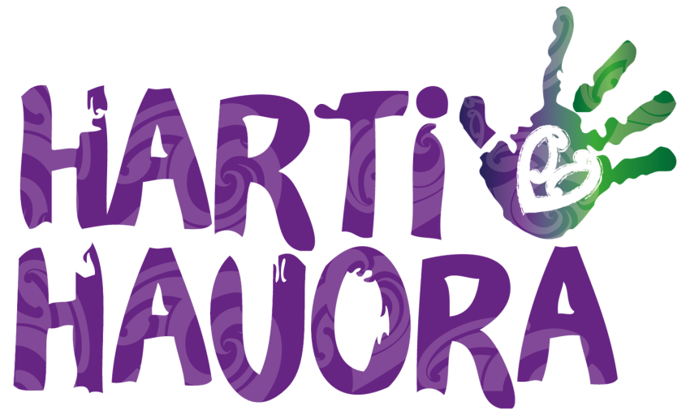
An invitation
You are invited to take part in this research because you are a parent/caregiver of a child currently in Waikato Hospital. This study is looking at wellbeing for children.
It is your choice to take part or not. If you don’t want to take part, you don’t have to give a reason and you and your child will receive the same care. If you do want to take part now, but change your mind later, you can pull out of this research at any time. If you choose to pull out of this research, we will use the information that has already been collected but we will not collect any more information from you or your whānau.
This Participant Information Sheet will help you decide if you’d like to take part.
It tells you:
- why we are doing the research (or the study)
- what taking part would involve
- what the benefits and risks to you might be
- what will happen after the study ends
You do not have to decide today whether you want to take part or not. Before you decide you may want to talk about the study with other people, such as family, whānau, friends, or healthcare providers. Feel free to do this.
If you agree to take part, you will be asked to sign the Consent Form on the last page of this document. You will be given a copy of the Participant Information Sheet and Consent Form to keep.
This document is 6 pages long, including the Consent Form. Please make sure you have read and understood all the pages. We can also answer any questions you may have.

What is the purpose of the study?

The aim of this study is to find out about patient and whānau satisfaction with care. We will also look at access to health and other services for hospitalised children and their whānau. We are interested in services and care that can be provided on top of the care you are receiving for your child’s current illness. We hope this might lower the chances of children needing to go back to hospital in the future. This study will help us look at the best ways to keep whānau well and healthy.

If you agree to take part in this study you will be randomly allocated to take part in either the ‘intervention group’ or ‘no intervention’ group. Like the flip of a coin - you will have equal chance of being in either group.

Both groups will be asked a series of questions.

What will my participation in the study involve?
A research assistant will explain the study to you and ask for your consent to take part.
Questions
The research assistant will ask you a set of questions about your whānau wellbeing. You will also be asked about your satisfaction with hospital care right before or after your child is discharged home. You may be asked questions about your access to and use of a range of health and wellbeing services.
It should take between 20-40 minutes to ask all the questions, but the total time will depend on some of the answers, and on what group you are in. An iPad will be used to collect the answers that you give. Where possible, these questions will be asked somewhere private.
You do not have to answer any questions that you find too sensitive, or that make you uncomfortable, and you can stop answering questions at any time. You can answer the questions in English or te reo Māori.
Participants who have identified as being smokers may be contacted to participate in a sub-study involving smoking cessation. For both groups this will involve being phoned to ask about quit attempts and preferences for nicotine replacement therapy (NRT) products. We will provide all parent/caregivers and household members with publically funded NRT and one group will also be supplied with free NRT Nicorette inhalators. This NRT is not publicly funded so we will provide up to a week’s supply free to help assist smoking cessation efforts.
Information from records
With your consent, health information about your child’s hospital visit will be collected from your child’s medical records. All information will remain confidential, or private, and will not be looked at by anyone else. Any information that is not about this study will not be looked at. With your consent we will also collect information from outside of your child’s hospital medical records. This includes information about whether your child is enrolled with a GP and GP records, whether they are enrolled in oral (or dental) health services, and whether your child has had their Well Child/Tamariki Ora Health Checks or their immunisations. We will not be collecting any personal information from your child’s GP.

What are the possible benefits and risks of this study?
Taking part in this study may take some time to answer all the questions and you do not have to answer any questions if they make you feel too uncomfortable. We will try to make sure that the questions are being asked at a time, and in a place, that works for you and you can stop at any time.
You will still receive the same care from the hospital, your doctor and other health services. Your child’s and your own usual medical care will not be affected in any way by participating in the study, or by declining to participate or withdrawing from the study at any time.
You may not directly benefit from the study. However, new findings from this study will help the people who fund, provide and deliver health services find out how to better support whānau with a child in hospital. This study may be of benefit to the greater population.
The information that you share with us will be treated with respect, privacy, protection and care.

Who pays for the study?
This study is funded by a research grant provided by the Health Research Council (HRC) of New Zealand.

What if something goes wrong?
If you were injured in this study, which is very unlikely, you would be eligible to apply for compensation from ACC just as you would be if you were injured in an accident at work or at home. This does not mean that your claim will automatically be accepted. You will have to lodge a claim with ACC, which may take some time to assess. If your claim is accepted, you will receive funding to assist in your recovery.
If you have private health or life insurance, you may wish to check with your insurer that taking part in this study won’t affect your cover.

Confidentiality
The information you provide will be only accessible to members of the research team. The study files and all other information that you provide will remain strictly confidential, unless there is an immediate risk of serious harm to yourselves or others. No material that could personally identify you will be used in any reports on this study. When the study ends, your records will be stored for at least 10 years in a secure place at the Waikato District Health Board. All computer records will be password protected. All future use of the information collected will be strictly controlled in accordance with the Privacy Act.
The study findings will be published, but there will be no identifying information included, so there is no way that anybody could identify you from what is reported.

What are my rights?
If you have any questions or concerns regarding your rights as a participant in this study, you may wish to contact an independent Health and Disability Advocate. This is a free service provided under the Health and Disability Commissioner Act:

Free phone: 0800 555 050
Free fax: 0800 2787 7678 (0800 2 SUPPORT)
Email: advocacy@hdc.org.nz

Or For Māori health support, please contact:
Te Puna Oranga (Waikato DHB Māori Health Unit), Hockin Building, Level 1, Pembroke St, P.O. Box 934, Hamilton. Ph: (07) 834 3628 Fax: (07) 834 3619.

You can also contact the health and disability ethics committee (HDEC) that approved this study:

Phone: 0800 4 ETHICS
Email: hdecs@moh.govt.nz

What happens after the study or if I change my mind?
If you take choose to take part in this study, you can choose not to answer any of the questions, and you can also change your mind and stop at any time. If you want to completely pull out of the study, you can do so at any time by contacting me via my contact details below. You are also very welcome to ask any other question about the study by contacting us at the email address below.

Who do I contact for more information or if I have concerns?

Dr Nina Scott, Chronic Conditions Advisor, (Lead Investigator)
Te Puna Oranga, Hockin L1
Pembroke Street
Waikato District Health Board
Hamilton, 3204
Email: nina.scott@waikatodhb.health.nz
Phone: 839 8899 ext 97548

Dr Amy Jones, Project Manager
Te Puna Oranga, Hockin L1
Pembroke Street
Waikato District Health Board
Hamilton, 3204
Email: amy.jones2@waikatodhb.health.nz
Phone: 839 8899 ext 97548

Please keep this brochure for your information.
Thank you for reading about this study

Consent Form
Please indicate you consent to the following

I have read, or have had read to me in my first language, and I understand the Participant Information Sheet.

I have been given enough time to consider whether or not to participate in this study.
I am satisfied with the answers I have been given regarding the study and I have a copy of this consent form and information sheet.
I understand that taking part in this study is voluntary (my choice) and that I may withdraw from the study at any time without this affecting my medical care.
I consent to the research staff collecting information about my child’s health from their hospital medical records from Midland Region District Health Boards.
I consent to the research staff collecting health data about my child’s and my health (including dental care enrolment, GP enrolment, immunisation, smoking cessation (‘Once and for all’ – Pinnacle), gambling addiction services and Well Child/Tamariki Ora checks) from health databases.
I consent to research staff accessing GP records for my child, including information relating to referrals and visits.
If I decide to withdraw from the study, I agree that the information collected about me up to the point when I withdraw may continue to be processed.
I agree to an approved auditor appointed by the New Zealand Health and Disability Ethic Committees, or any relevant regulatory authority or their approved representative reviewing my relevant medical records for the sole purpose of checking the accuracy of the information recorded for the study.
I understand that my involvement in this study is confidential and that no material, which could identify me personally, will be used in any reports on this study.
I know who to contact if I have any questions about the study in general.
I understand my responsibilities as a study participant.
I wish to receive a summary of the results from the study. | Yes □ | No □

Declaration by participant:
I hereby consent to take part in this study.

Child’s name:
Participant’s name (caregiver/parent):
Signature: | Date:

Declaration by member of research team:

I have given a verbal explanation of the research project to the participant, and have answered the participant’s questions about it.

I believe that the participant understands the study and has given informed consent to participate.

Research Assistant’s name:
Signature: | Date:

Consent Form
Please indicate you consent to the following

I have read, or have had read to me in my first language, and I understand the Participant Information Sheet.

I have been given enough time to consider whether or not to participate in this study.
I am satisfied with the answers I have been given regarding the study and I have a copy of this consent form and information sheet.
I understand that taking part in this study is voluntary (my choice) and that I may withdraw from the study at any time without this affecting my medical care.
I consent to the research staff collecting information about my child’s health from their hospital medical records from Midland Region District Health Boards.
I consent to the research staff collecting health data about my child’s and my health (including dental care enrolment, GP enrolment, immunisation, smoking cessation (‘Once and for all’ – Pinnacle), gambling addiction services and Well Child/Tamariki Ora checks) from health databases.
I consent to research staff accessing GP records for my child, including information relating to referrals and visits.
If I decide to withdraw from the study, I agree that the information collected about me up to the point when I withdraw may continue to be processed.
I agree to an approved auditor appointed by the New Zealand Health and Disability Ethic Committees, or any relevant regulatory authority or their approved representative reviewing my relevant medical records for the sole purpose of checking the accuracy of the information recorded for the study.
I understand that my involvement in this study is confidential and that no material, which could identify me personally, will be used in any reports on this study.
I know who to contact if I have any questions about the study in general.
I understand my responsibilities as a study participant.
I wish to receive a summary of the results from the study. | Yes □ | No □

Declaration by participant:
I hereby consent to take part in this study.

Child’s name:
Participant’s name (caregiver/parent):
Signature: | Date:

Declaration by member of research team:

I have given a verbal explanation of the research project to the participant, and have answered the participant’s questions about it.

I believe that the participant understands the study and has given informed consent to participate.

Research Assistant’s name:
Signature: | Date:

